MNDMIC016

RCHDEA002

MKHRHU002

Eco3021S group project

Topic 2: Academic paper assessing the determinants of child hunger.



**Determinants of child hunger**

* 1. **Abstract**

The overall purpose of this paper was to determine the factors that effected child hunger. The results of this paper were limited to the variables used in the data set provided. Child hunger is a complex topic with many different determinants that go beyond the variables included in the data set. There were several single and multiple regression models run with variables relating to child hunger. Previous literature research was used to determine several of these variables. This paper found that variables relating to early childhood development centres were mostly significant, as well as race and household income. Variables such as gender and number of people living in a house were also significant. Age and whether the person in the family received a UIF were insignificant variables. The coeffecient of determination of the main full model was 22%. The main recommended policy relates to the investment into ECD’s.

* 1. **Introduction**

This paper will dive into the very important topic of child hunger in South Africa in 2021, post the 2020 Coronavirus pandemic lockdowns. We will explore the numerous explanatory variables and factors which will illustrate the causes of child hunger in South Africa 2021. This is an absolutely crucial and heartbreaking topic that we feel very strongly about!

This topic is exceptionally important on both an ethical, moral and economic level. Our beloved children are the future of this already struggling country. They are the next generation filled with so much hope and aspirations. How are they meant to develop into the citizens we want them to be, if they are embedded with hunger from such an early age?

The research question addressed is the possible causes of child hunger in South Africa, 2021. We will also explore the effects of the Coronavirus pandemic on child hunger. There have been numerous lockdowns to date, with the strictest one being from the end of March to May 2020. It is evident that millions of people have been impacted by these lockdowns, but we want to explore the extent to which child hunger has been a result of these effects.

This paper will contribute to existing literature by placing an extra emphasis on the impact of the Coronavirus pandemic on child hunger. We will explore many factors, directly and indirectly caused by the pandemic, that could’ve had an additional impact on child hunger. Examples of these factors include the various lockdowns, extra job losses and lack of trade during certain months.

Previous literature papers similar to our research question found that there were many factors that caused childhood hunger. More specific to South Africa, the one research paper found that a stop in early childhood development centers as a result of Covid, increased the number of households that had at least one child who went hungry. Our main results were majority as expected as and in line with previous research papers. With the most significant determinant of childhood hunger being the household’s income.

* 1. **The child hunger research and evaluations thus far**

A survey conducted between May and June of 2020 by the National Income Dynamics Study – Coronavirus Rapid Mobile Survey (NIDS-CRAM) captured concrete evidence that there had been a strong and drastic increase in both adult as well as child hunger. (Berg, Patel, & Bridgman, 2020). Within this survey it was found that almost half of all the surveyed households had run out of money for food during the month of April 2020 (Berg, Patel, & Bridgman, 2020). When comparing these results with earlier surveys, such as the annual General Household Survey from 2002 until 2018, showed that all the positive momentum in reducing child hunger and food security through the Child Support Grant had come to drastic stop and almost completely reversed as a consequence of the national lockdown due to the COVID-19 pandemic (Berg, Patel, & Bridgman, 2020).

The initial lockdown measures undertaken by the South African government led to 3 million citizens losing their jobs (Blerk, 2021). What is also more concerning is that the effects of the lockdown were disproportionately felt by lower income citizens. There was a 31% decrease in employment amongst the poorest 50% of citizens, compared to only a 3% decrease in the richest 25% (Blerk, 2021). This, of course, had a significant impact on households, especially children.

A combined 11.5 million children in schools enrolled in the National School Nutrition Programme and 3-5 year olds in early childhood development programmes received daily meals from aforementioned programmes (Blerk, 2021). With the lockdown measures, these feeding programmes halted (Blerk, 2021). The government’s lacklustre response to the disruption resulted in civil society organisations filing urgent applications to the High Court to “protect children’s rights to basic nutrition” (Blerk, 2021) by asking the High Court to reopen the feeding programmes (Blerk, 2021). The High Court granted their request. Eventually, the government also allocated R41bn for “social relief efforts” (Blerk, 2021).

Early childhood development centers have proved to be an essential way to combat child hunger, especially in middle to lower class areas. It is found that most of these ECD (early childhood development will now be referred as this) places supply nutritional food to the children attending it. The Corona virus pandemic had a large impact on the running of these ECD centers (Kika-Mistry, 2021). The authors found that pre pandemic, thirty-nine percent of respondents indicated that at least one child between the ages of zero to six attended an ECD in February 2020 (Kika-Mistry, 2021). This percentage dropped to as low as seven percent post pandemic lockdown, in August 2020 (Kika-Mistry, 2021). It is encouraging to see that this percentage has significantly recovered to thirty-six percent in the latest round of questions during May 2021 (Kika-Mistry, 2021). Other relevant results from the paper involve the association between improvement in households’ ability to afford fees and the increase in at least one child aged 0-6 per family attendance at an ECD center (Kika-Mistry, 2021). There was also a link between the ECD being open and schools being open (Kika-Mistry, 2021). We viewed our question in a broader manner than this paper did. We looked at various other factors in determining childhood hunger.

The second early child development paper tracked how Early Childhood Development (ECD) programmes were affected by the pandemic. The research shows that the attendance of children at ECD programmes, which included feeding schemes, did not recover to pre-pandemic levels after the lockdown restrictions (Kika-Mistry, Early childhood development and lockdown in South Africa, 2021). There are various reasons for this cited by the research. The first reason is attributed to the closure of many programmes: thirty-one percent of programmes reported being temporarily closed and six percent reported permanent closure (Kika-Mistry, Early childhood development and lockdown in South Africa, 2021). The second reason is “the low fee collection” (): household ability to pay ECD programme fees decreased significantly, with sixty-eight percent of household respondents not being able to afford the fees (Kika-Mistry, Early childhood development and lockdown in South Africa, 2021).

The paper, (BMC Public Health, 2017), analyzed the factors associated with child hunger among food insecure households. Even though this paper was based in Bangladesh, the findings from this paper are significant for a country such as South Africa, as Bangladesh and South Africa are both third world countries. The results of this paper aren’t as important for us doing research in South Africa, but what is more important is the independent variables that the authors deemed significant in determining childhood hunger. These include: sex of the household head, household food insecurity status, educational status of household women and asset index (BMC Public Health, 2017). The authors also found that of all the significant independent variables, degree of household food insecurity status was the most important predictor of child hunger (BMC Public Health, 2017). This paper was extremely helpful in determining what factors we could use in determining child hunger. The authors of this paper took a broad approach in determining child hunger by including many potential relevant explanatory variables (BMC Public Health, 2017). As much as it is always important to include all relevant variables in a regression analysis, we were restricted as to which variables we could use, based on the limited data that was recorded in NIDS.

The paper, (Deborah Balk, 2005), analyzed child hunger in the developing world using both environmental and household-level factors. The author found that household-level factors explained more variation in child hunger (Deborah Balk, 2005). This piece of information is extremely vital for understanding certain factors that cause childhood hunger. It is of the impression that families who live in better ‘environmental’ areas would more than likely have better access to food. An example of this would be a family who lives near a farm, compared to a family that lives in a very secluded area. However, this paper found that the stronger indicator to child hunger was, in fact, household factors (Deborah Balk, 2005).

The paper, (Berg, 2021), has acknowledged that child hunger during the pandemic has not only increased from pre-pandemic levels but have also “remained stubbornly high” since June 2020 (Berg, 2021). According to the survey, households who had exhausted their money for food were 47% of respondents during Wave 1. In comparison to Wave 5, although this proportion decreased to 35%, it is still significantly high (Berg, 2021). During Wave 1, 23% of respondents as well as 15% of respondents reported household hunger and child hunger, respectively (Berg, 2021). In comparison to Wave 5, household hunger did decrease substantially from 23% to17%, whilst child hunger decreased slightly to 14% (Berg, 2021). The survey not only investigated levels of hunger among the population, but also the severity of hunger as well. Child hunger, unusually, was higher than household hunger for hunger reported once in the past seven days (34% and 33% respectively) (Berg, 2021).

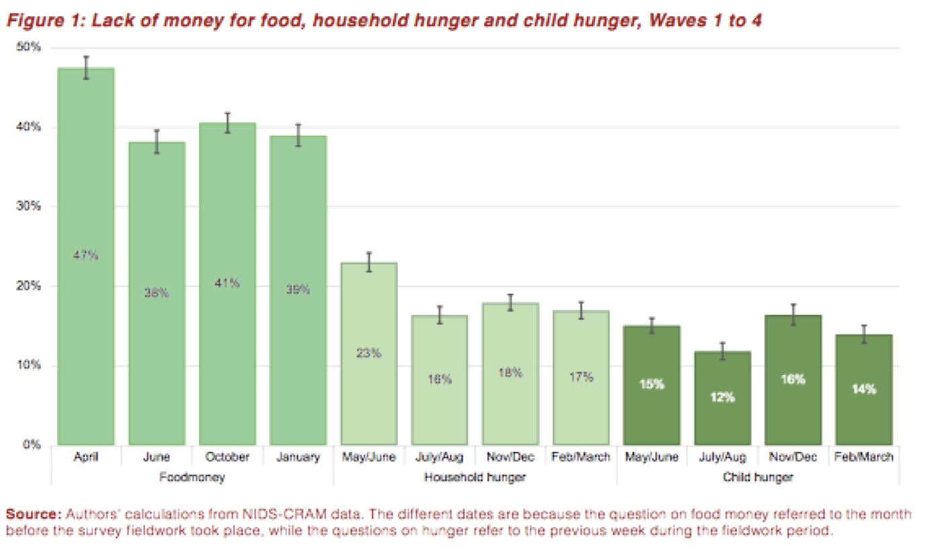

The above graph, which is a comparison between waves 1-4 of the (NIDS- CRAM) survey, shows alarming statistics of how food money, household hunger as well as child hunger had changed throughout the four surveys.

* 1. **Preliminary data section**
     1. Data description

The data from NIDS is an example of unbalanced panel data. Responses were recorded on five different dates, referred to as wave one to wave five, and the questions were asked to the same households (Kim Ingle, 2021). There were times in which the survey was not responded to, due to death, people refusing to answer or immigration (Kim Ingle, 2021). There were two different types of attempts to contact respondents, namely: calling and SMSs (Kim Ingle, 2021). In wave one, they managed to get a total of 7,073 successful responses (Kim Ingle, 2021). This could be argued that it is not representative enough of the population. We know that a good sample should be representative and random. The main restriction or limitation that the researches faced is that they were not able to use NIDS-CRAM to conduct household-level analysis (Kim Ingle, 2021). They also state that it is not recommended to use NIDS-CRAM to calculate provincial totals as it was designed to be a national measure (Kim Ingle, 2021). The main variables included were: geographical variables, employment, income, occupation, industry and monetary values. (Kim Ingle, 2021) There were also open-ended questions asked (Kim Ingle, 2021).

* + 1. Preliminary data analysis

Our dependent variable used is w5_nc_fdcyn. The respondents gave a response of “Yes” if a child in the household had experienced hunger in the last 7 days, and they gave a response of “No” if the child hadn’t experienced hunger in the last 7 days. We then cleaned our dependent variable by generating a new variable called “Hunger”. After this, we ran the code “su hungry”, this summarized the variable hunger and showed us what proportion of the respondents indicated a “Yes” and “No” to the hunger question. 15.75 % of respondents indicated that a child has experienced hunger in the last seven days.

Our first independent variable we used was household income. Respondents were asked what their household income was in March. We cleaned this variable by removing some non-responses, and generated a new variable called “income”. We then summarized this variable and found that the average household income in March was R5175.32. We decided to tabulate household income against hungry and found that the average household income for hungry was R2564.82 and for not hungry was R5710.13. We then displayed this on a bar graph to illustrate the comparison of household income in terms of “hungry” and “not hungry”.

Figure 2: Bar graph displaying household income for hungry and not hungry

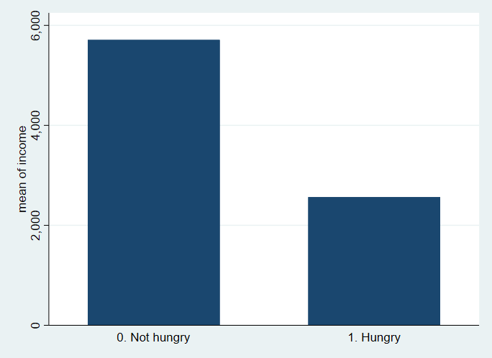

Our next independent variable we included was employment status. Respondents were asked if they were employed at the time being. We believe this could also be a significant decider to see if a child in the house experienced hunger as the parent would likely not be able to afford to feed their child unless they were given a grant from the government. We cleaned this variable by removing those who didn’t respond as well as those who aren’t economically active. We generated a new binary variable for just those employed (1) and unemployed (0). We then found that 62.87% of people were employed from this new variable.

Race was our next independent variable. Due to the severe inequality that is still prevalent in South Africa today, we thought that race might explain some variation in our dependent variable. We cleaned our race variable by generating four separate binary variables for the four races recorded, namely: Black/African, White, Coloured and Indian. There was no missing data as everyone indicated what race they are. We noticed that there is proportionately more “Black/African” responses in the survey than any of the other race variables which may or may not skew our results.

Unemployment insurance fund is our next independent variable. This is the independent variable we chose to include based on the sub-analysis topic. This independent variable will be unique to our linear regression models associated with responding to sub-analysis question and won’t be included in our main linear regression models. We want to test if households who received an unemployment insurance fund were associated with not having a child who experienced hunger during the survey. This may or may not be significant. As parents may have spent the grant on something other than feeding their children. Although this is an unlikely outcome, parents could’ve spent the grant on paying their rent, or even drugs. However, we do expect that the majority of parents would’ve spent the grant on feeding their children and thus it would be a significant variable. We then compared the UIF responses to the hungry variable on a graph. It Illustrates how there is a much larger proportion of people whose children were hungry that didn’t receive a UIF compared to the people who did receive a UIF.

Figure 3: Bar graph comparing UIF and no-UIF in terms of hunger

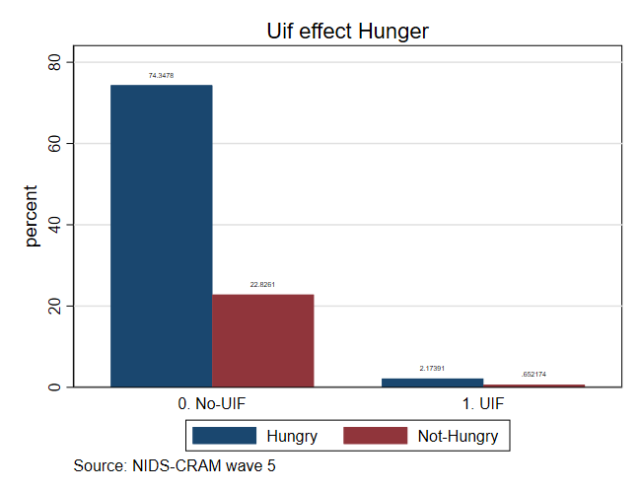

Our next independent variable used was number of people living in the house. Respondents were asked as to how many people were living in the house. We estimate that this could be a significant variable as it would be harder for the parents to feed all the children in their house, the more children they have, ceteris paribus. We cleaned this variable and renamed it “peopleinhouse”. All respondents answered this question. The average number of people living in the house was 5.24. We compared this variable to the hungry variable on a bar graph as well as a tab stat. The average number of people living in the house for those whose child experienced hunger was 6.8 compared to 6.2 people for those who didn’t have children that experienced hunger.

Figure 4: Bar graph showing number of people in household in terms of hunger

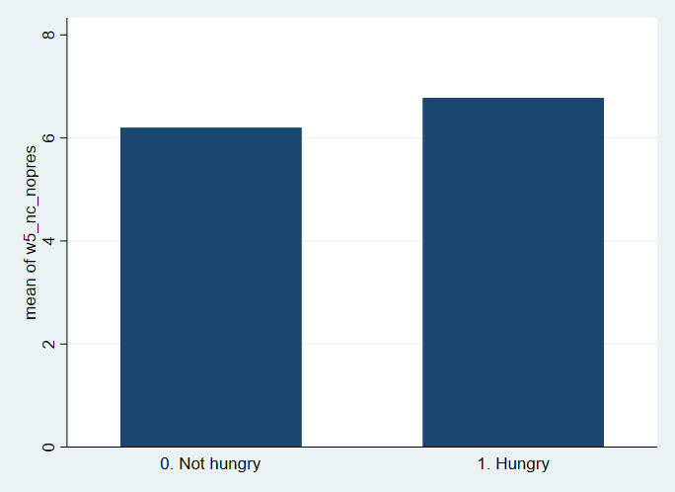

Gender is our next independent variable. We believe this could be the least significant of all our other independent variables used but should still explain some variation in our dependent variable. There might’ve also been some omitted variable bias if we left out this variable, as there is most likely a correlation between your household income and your gender due to the gender wage gap that exists in South Africa. We cleaned the variable and created a new binary variable called “Female”. We then created a bar graph comparing the female variable and the hungry variable. We can see from the graph that there was a higher proportion of children that were hungry under “female” compared to “male”.

Figure 5: Bar graphing comparing Male and Female in terms of hunger

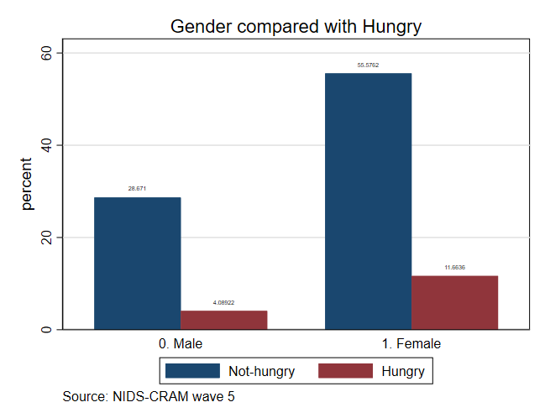

Age was our next independent variable. In the age dataset, the range is between 18 and 100 years old. However, we are only interested in the ages of people that would be potentially looking after a child and having to earn income to supply food for that child. We thus only included people in the labour force between the ages of 18 and 64. Another important thing to note is that there could’ve been omitted variable bias once again if we left this variable out, due to the potential positive correlation between income and age.

The next four independent variables related to an early childhood development centre (ECD) as this was a very significant factor and determinant of child hunger in previous literature review papers:

The first ECD variable included was if any of the children attended an ECD in February 2020. This was a binary variable.

The second ECD variable included was if the child received a meal from the ECD program. This was a binary variable.

The third ECD variable was if the respondent know of an affordable ECD centre within 5km. This was a binary variable.

The fourth ECD variable was if someone in the house was able to afford ECD fees. This was a binary variable.

* + 1. Descriptive statistics table

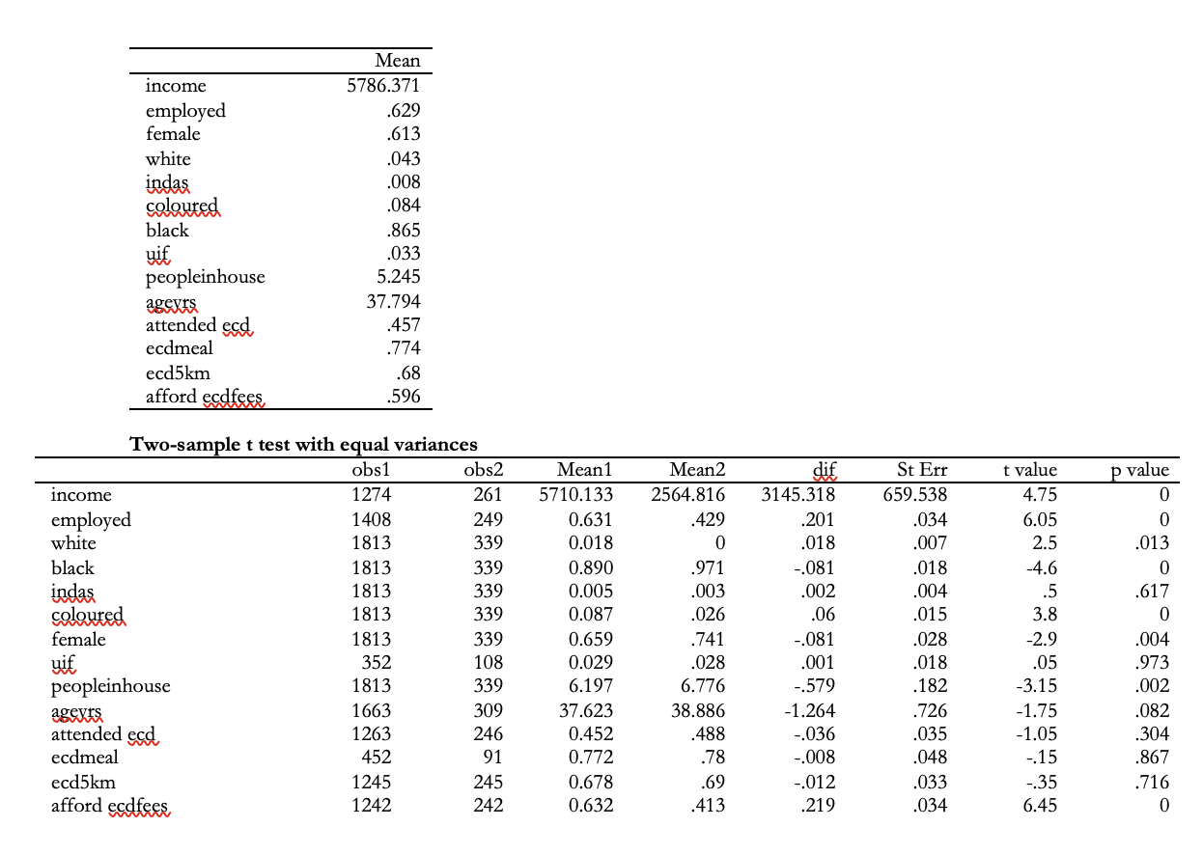

* 1. **Regression analysis data**

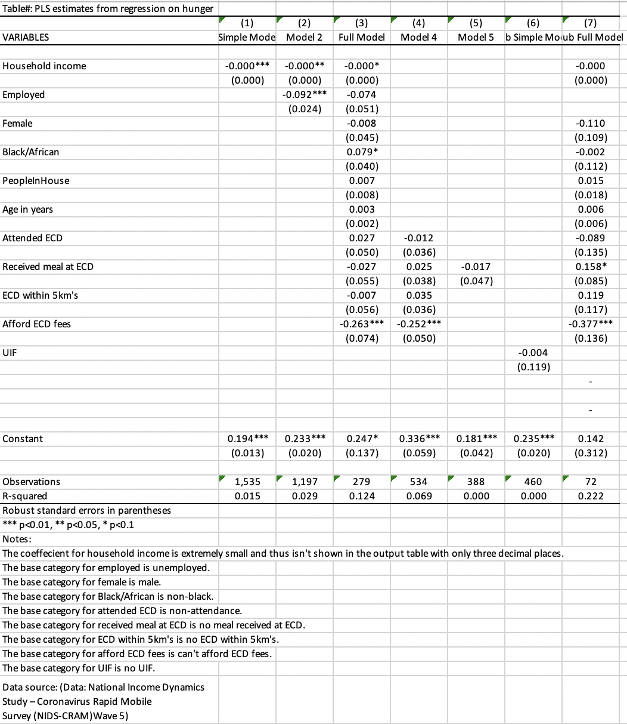

* 1. **Discussion and regression analysis**

After the cleaning of all of the dependent and independent variables, the regression models were run on Stata.

It is important to note that the dependent variable, we have renamed as “hungry”, is a binary variable. The output is either 1, if the respondent had a child that experienced hunger, or 0, if the respondent didn’t have a child that experienced hunger. Thus, the models are called linear probability models. The coefficients will then measure changes in probability of success when an independent variable change, ceteris paribus. Therefore, an additional unit of independent variable one is associated with a beta one increase or decrease in the probability of the dependent variable equaling one, ceteris paribus. In our specific case, it is the probability of a respondent’s child experiencing hunger.

The following relates to the simple and multiple linear regression model assumptions. Out of the four simple linear regression model assumptions, assumptions one to three are not violated. Namely: the population regression is linear in its parameters, there is a random sample size and there is variation in x. It is more than likely that assumption four does not hold, which is the zero conditional mean assumption. It is also uncertain whether assumption 5, homeskedacity, holds. Thus, it cannot be concluded that the independent variable in the simple linear regression model is unbiased. With regards to the multiple linear regression models, assumptions one to three hold once again. However, assumption three is now no perfect collinearity. It is once again uncertain whether assumption four and five hold. And assumption six, normality of u, is also uncertain to hold. Thus, it also cannot be concluded that the independent variables of the multiple linear regression models are unbiased.

Model 1: Simple linear regression model with income

The income coefficient was -4.65e-06. This means that a 1 unit increase in income is associated with a 4.65e-06 decrease in the probability of a child experiencing hunger in the house, ceteris paribus. Contrary to our estimation, our independent variable income in our simple linear regression model had a coefficient of determination of only 1.5%. This means that income only explains 1.5% of the variation in our dependent variable hungry. However, the income variable was statistically significant at the 1% alpha probability level as the probability was 0.6%.

Model 2: Multiple linear regression with two independent variables (employed and income)

We now included the independent binary variable “employed” to our model. We can now see what effect whether a person is employed has on the probability of a child experiencing hunger in the household. The employed coefficient is -0.091. This means that if a person is employed, the probability of a child in the house experiencing hunger decreases by 0.091. The employed variable is statistically significant at the 1% alpha probability level also. The coefficient of determination has increased to 2.95%. However, this is still very low. Lastly, we can see that the coefficient of our first independent variable, income, has increased. The results of this specific regression model are in line with the previous literature research we found. Employment and child hood hunger being negatively correlated was a common theme in the research papers.

Model 3: Full multiple linear regression model

We have now included all ten independent variables that we intended to include in our multiple linear regression model. In addition to the income and employed variables, we now also added a race variable, a gender variable, a variable capturing the amount of people that live in the household as well as the ECD variables. Due to the “Black/African” respondents making up most of the respondents in the survey, we decided to only include this binary race variable instead of all of the binary race variables. Therefore, the variable would result in a response of 1 if the respondent is Black/African and 0 if the respondent isn’t Black/African. The coefficient of determination of our final model is 12.39%. Although this is particularly small, it does not necessarily mean that our model isn’t accurate. We notice that the coefficient for income has once again increased, potentially implying some upwards bias from the variables that were added. The coefficient for employed has also increased from the previous model, another potential case of upwards bias. The coefficient for the female variable was 0.008. This means that if the respondent was a female, it increases the probability of a child experiencing hunger in the household by 0.008. However, the female variable is not statistically significant at the 5% or even 10% level. The coefficient for the Black/African variable is 0.079. This means that the respondent being black is associated with a 0.079 increase in the probability that the respondent’s child experienced hunger. This variable is statistically significant at the 1% level. The variable included, peopleinhouse, has a coeffecient of 0.007. This means that an increase in the people in your house by one unit, is associated with a 0.007 unit increase in probability of a child experiencing hunger in the house. This variable is not statistically significant at the 5% level or even the 10% level.

Model 4: Multiple linear regression model with just ECD variables

We now formulated a regression model with just the ECD variables that we chose to include in our project. The coeffecient of determination is 6.95%. Another particularly low explanation of variation. It was interesting to note that in this particular model, attended_ecd, ecdmeal and ecd5km are all statistically insignificant at the 5% and 10% level. The only statistically significant variable is afford_ecdfees. Afford_ecdfees and attended_ecd both had negative coefficients, which was in line with previous literature research. Contrary to previous research, ecdmeal and ecd5km both had positive coefficients. This implies that if a child received a meal and/or lives within 5km’s of an ECD, it increases the probability of a child experiencing hunger.

Model 5: Multiple linear regression model with ecd attend = 1 and ecd meal

In this specific regression model, we wanted to see the effect that getting served a meal at a ECD has on child hunger. Based on the previous literature research and the specific paper, (Kika-Mistry, Early childhood development and lockdown in South Africa, 2021), there was empirical evidence that many of these children relied on these ECD’s to provide them with a meal. We had to include the attended_ecd variable as we were only interested in the results of someone who did attend an ECD and received a meal. Thus, we set a constraint that attended_ecd = 1. This model had an extremely low coeffecient of determination of 0.3%. The results were as expected with ecdmeal having a negative coeffecient meaning children who received a meal is associated with a lower probability of being hungry.

Sub question analysis: UIF effect on hungry children

Model 1: Simple linear regression

In this simple linear regression model, we analyzed the effect of someone either receiving or not receiving their UIF grant on the probability of a child experiencing hunger. The coeffecient of determination for this model is extremely low once again. The UIF variable had a coeffecient of -0.004. This means that if someone received a UIF, it decreases the probability of the child being hungry by 0.004 units. However, the UIF variable was found to be statistically insignificant at both the 5% and 10% level. The t-value is -0.03 and does not lie in the 95% confidence interval. These results were not as expected, either there was not enough data to formulate a sufficient regression model with this variable, or the funds from the UIF wasn’t being used to feed the children.

Model 2: Full multiple linear regression with independent variable UIF

This multiple linear regression model included all our previous independent variables, as well as the inclusion of the UIF binary variable. This model had the highest coeffecient of determination of all of our previous models, at 22.16%. However, there were once again many statistically insignificant variables at both the 5% and 10% level. The list of insignificant variables includes: income, female, black, peopleinhouse, ageyrs, attended_ecd and ecd5km.

Thus, to answer the required sub question regarding government grants, we have not found evidence of statistically significant differences between households who receive government grants compared to households who don’t. In both models in which we included UIF as a variable, it was statistically insignificant. This is contrary to our estimation as you would think that households who receive government income grants have a lower likelihood of having a child that has experienced hunger. Possible reasons for this not being the case are the likelihood of the households having too many children for the grant to cover. Another possible reason is that the households are using the income for reasons other than feeding their children. Lastly, there is a possibility that we do not have enough recorded data for those who received a UIF grant to make a statistical conclusion about the possibility of a child in that household experiencing hunger.

* 1. **Conclusion**

In conclusion, there are numerous factors that determine child hunger and it is highly unlikely to completely explain the variation in child hunger using only a certain number of variables found in the data set. In line with the previous literature review, evaluating the impact of early childhood development centers on child hunger, the ECD variables that were used in this paper weren’t as significant as previous research concluded them to be. However, they were still significant to a certain degree. Race was found to be a statistically significant determinant of childhood hunger, which was in line with previous research. Contrary to previous thoughts, gender and the amount of people living in the house were not statistically significant. With regards to the sub question, the UIF variable was also found to be statistically insignificant in the simple linear model. However, when including the UIF variable in the full model, the coeffecient of determination increased by over ten percent.

There were also numerous other significant findings relating to the variables used. The average income of non-hungry households was more than double that of hungry households. There was still a higher portion of hungry households that received a UIF than non-hungry households who received a UIF. The average people living in a household is higher for hungry households.

Overall, the majority of the findings were in line with previous research. It is imperative to note the importance of early childhood development centers in combatting child hunger. This paper, as well as many previous academic papers, have shown that affording ECD fees and other ECD variables play a significant role in determining whether a child will go hungry. This ECD topic will be the focus of the policy recommendations.

**1.7 Policy recommendations**

It is essential for the government to continue the funding of public early childhood development centres as well as consider building many more centres. The government can also incentivize the continued investment of private early childhood development centres by offering them tax reductions or giving them grants. A lot of poor and rural children rely on ECD’s for their only meal of the day, which signifies the importance of these centres. These kids cannot afford for these centres to close again, as was the case with Covid lockdowns, which is why the government must ensure that these centres can be run in a Covid reliant way with all the correct personal protective equipment. The successful running of many ECD’s that provide meals will obviously not solely solve the problem of child hunger in SA, but it will definitely help improve the current situation.

**(word count before reference list: 4938)**

**1.8 Reference list**

# Bibliography

Kika-Mistry, G. W. (2021, July 8). Early Childhood Development in South Africa during the COVID-19 Pandemic: Evidence from NIDS-CRAM Waves 2 - 5. South Africa.

BMC Public Health. (2017). Factors associated with child hunger among food insecure households in Bangladesh.

Deborah Balk, A. S. (2005). Child hunger in the developing world: An analysis of environmental and social correlates.

Kim Ingle, T. B. (2021, July 8). Panel User Manual. South Africa.

Berg, S. v. (2021, July 8). Food insecurity from South Africa. South Africa.

Kika-Mistry, G. W. (2021, May). Early childhood development and lockdown in South Africa. South Africa.

Blerk, J. &. (2021). Responding to Covid-19 in South Africa: social solidarity and social assistance. South Africa.

**Do file code:**